www. Anubis Great Danes . com
www. Gouda Great Danes . com
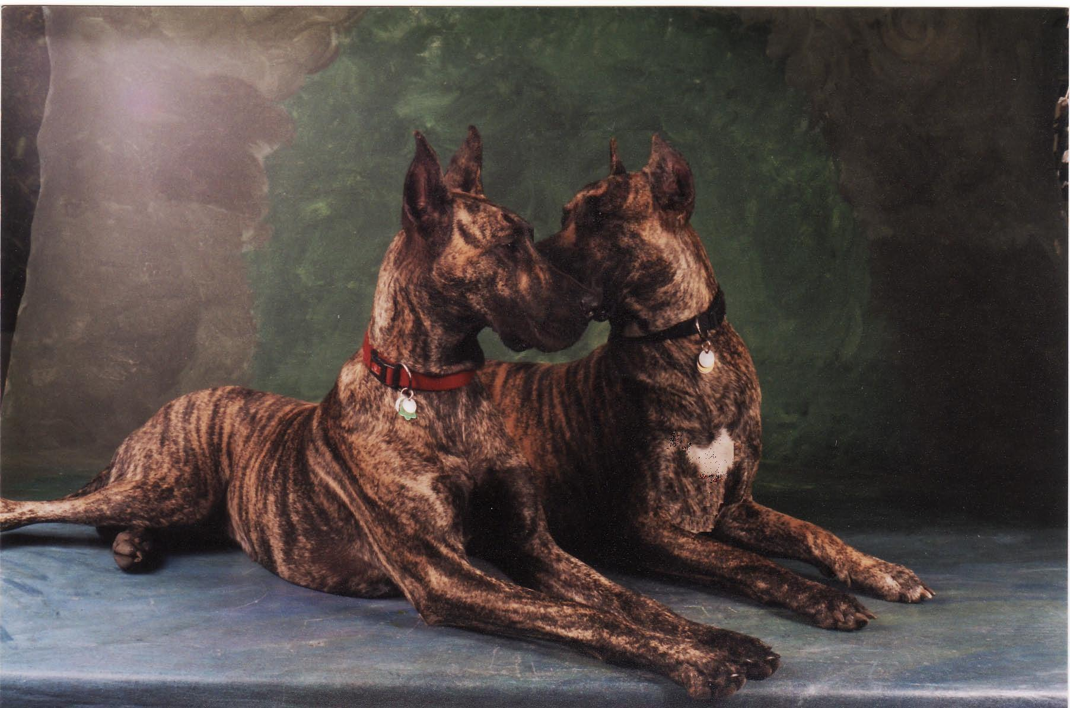

Certificate of purebred excellence
Great Dane

Dane’s name: Lobo Gouda Ancheniovich
Date of birth: May 24th. 2008
Colour: Brindle Sex: Male

Sire: Anubis Lion King Gouda AKC# WS16055505 “Co-owned, CAN- USA”
Dam: Nifirtiti Kennedy Gouda AKC# WS18768905 CKC# 1096796 CAN

Quality: Purebred – Top quality - champion bloodline pedigree
Value: $3,000 Purchase price was altered under “solely a pet” category. Non-breeding contract.
- Must be neutered – spayed before age 8 months.

Owner: Vince R. Ancheniovich
Address: Germany

Breeder: Anubis Great Danes
Gouda Great Danes, B.C. Canada
Dr. Paul Gouda; C.Chem. Ph.D. Breeder certified;
Nanaimo, B.C. Canada 250-619-7701 stamped & signed:
gouda@chemist.com …………………………………

www.anubisgreatdanes.com
www.goudagreatdanes.com

